Abstract
This report provides an integrated and extended comparison of five multitask deep learning models for brain MRI tumor classification and binary tumor segmentation. The analysis correlates the five supplied Word reports with the five executed Jupyter notebooks and uses the notebooks as the source of truth when a mismatch appears. The models are Custom U-Net Multitask, ResNet50 classifier with DeepLabV3+ segmentation, LinkNet with EfficientNet-B0, ENet, and DeepLabV3 with MobileNetV3-Large. The strongest overall model is Custom U-Net Multitask, which achieves 97.98% classification accuracy, 0.8383 Dice, and 0.7575 IoU. ResNet50 + DeepLabV3+ is the closest competitor, while ENet is the most parameter-efficient model. The one-epoch DeepLabV3-MobileNetV3 experiment is included as an undertrained baseline rather than a competitive model.

1. Project Overview
The project addresses a practical medical-imaging problem: classifying brain MRI scans into glioma, meningioma, no_tumor, and pituitary classes while also producing a tumor mask. The multitask design is valuable because classification provides the diagnostic category, and segmentation provides spatial evidence for localization. The comparison, therefore, evaluates both diagnostic performance and tumor localization quality.
Model | Input | Test set | Primary audit
Custom U-Net | 224x224 RGB | 988 cls / 849 seg | Best overall balance; strongest Dice and IoU
ResNet50+Dv3+ | 224x224 RGB | 1000 cls / 860 seg | Strongest short-training result;
LinkNet-EffB0 | 128x128 RGB | 1000 cls / 1000 mask rows | High ROC-AUC and compact pretrained.
ENet | 256x256 grayscale | 1000 cls / 860 seg | Best lightweight option; only 0.364M parameters
DeepLabV3-MNet | 128x128 grayscale | 1000 cls / 860 seg | Undertrained one-epoch baseline

2. Dataset and Split Summary
We have used the BRISC2025 dataset, which consists of 5,000 official classification training images and 1,000 official classification test images. The official test class distribution is 254 glioma, 306 meningioma, 140 no_tumor, and 300 pituitary. Segmentation masks are available for a subset of the data: 3,933 training masks and 860 official test masks. Images without segmentation masks are handled using blank masks in the multitask setup.
• Custom U-Net removes exact duplicate images using hashing; therefore, its final classification test set is 988 images, and its segmentation test set is 849 images.
• LinkNet keeps images without masks by assigning blank masks and evaluates on the official 1,000-image test set.
• ENet and DeepLabV3-MobileNetV3 report 1,000 classification test images and 860 available test segmentation masks.
3. Methodology and Architecture Comparison
All five notebooks use multitask learning, but they differ in backbone design, decoder strength, input resolution, color channel handling, number of epochs, and checkpoint selection method. These differences explain much of the final performance gap.

Model | Architecture | Input | Training method
Custom U-Net | Encoder-bottleneck-decoder with skip connections; classifier from shared representation. | 224x224 RGB | AdamW; classification CE with label smoothing; BCE + Dice for segmentation; best score balances F1 and Dice.
ResNet50+Dv3+ | Pretrained ResNet50 classifier plus SMP DeepLabV3+ ResNet50 segmentation branch. | 224x224 RGB | AdamW; CE + BCE; best checkpoint selected by validation loss; very strong in five epochs.
LinkNet-EffB0 | SMP LinkNet with EfficientNet-B0 ImageNet encoder and auxiliary classification head. | 128x128 RGB | AdamW; weighted CE + BCE/Dice; total loss uses 0.7 segmentation and 0.3 classification.
ENet | Lightweight encoder-decoder with a classification head from the deep encoder tensor. | 256x256 grayscale | AdamW; weighted CE + BCE/Dice; only 363,548 parameters.
DeepLabV3-MNet | torchvision DeepLabV3-MobileNetV3-Large with classifier head. | 128x128 grayscale | One epoch only; weights=None; severe undertraining and class-collapse.

Interpretation of Methodological Differences
• U-Net has the clearest segmentation advantage because skip connections preserve fine-grained spatial information from MRI images.
• ResNet50 + DeepLabV3+ benefits from pretrained ImageNet features, explaining its high accuracy despite only five training epochs.
• LinkNet and ENet show the benefit of lightweight architectures: LinkNet has a high AUC; ENet has the smallest parameter count.
• DeepLabV3-MobileNetV3 cannot be fairly judged as a mature model because the notebook trained it for only one epoch without pretrained weights.
U-Net excels at segmentation by preserving spatial details via skip connections. ResNet50 with DeepLabV3+ achieves strong accuracy, likely due to pretrained ImageNet features, even after only 5 epochs. LinkNet and ENet highlight the strengths of lightweight models—LinkNet with high AUC, ENet with minimal parameters. DeepLabV3-MobileNetV3 is difficult to assess due to limited training and the lack of pretrained weights.
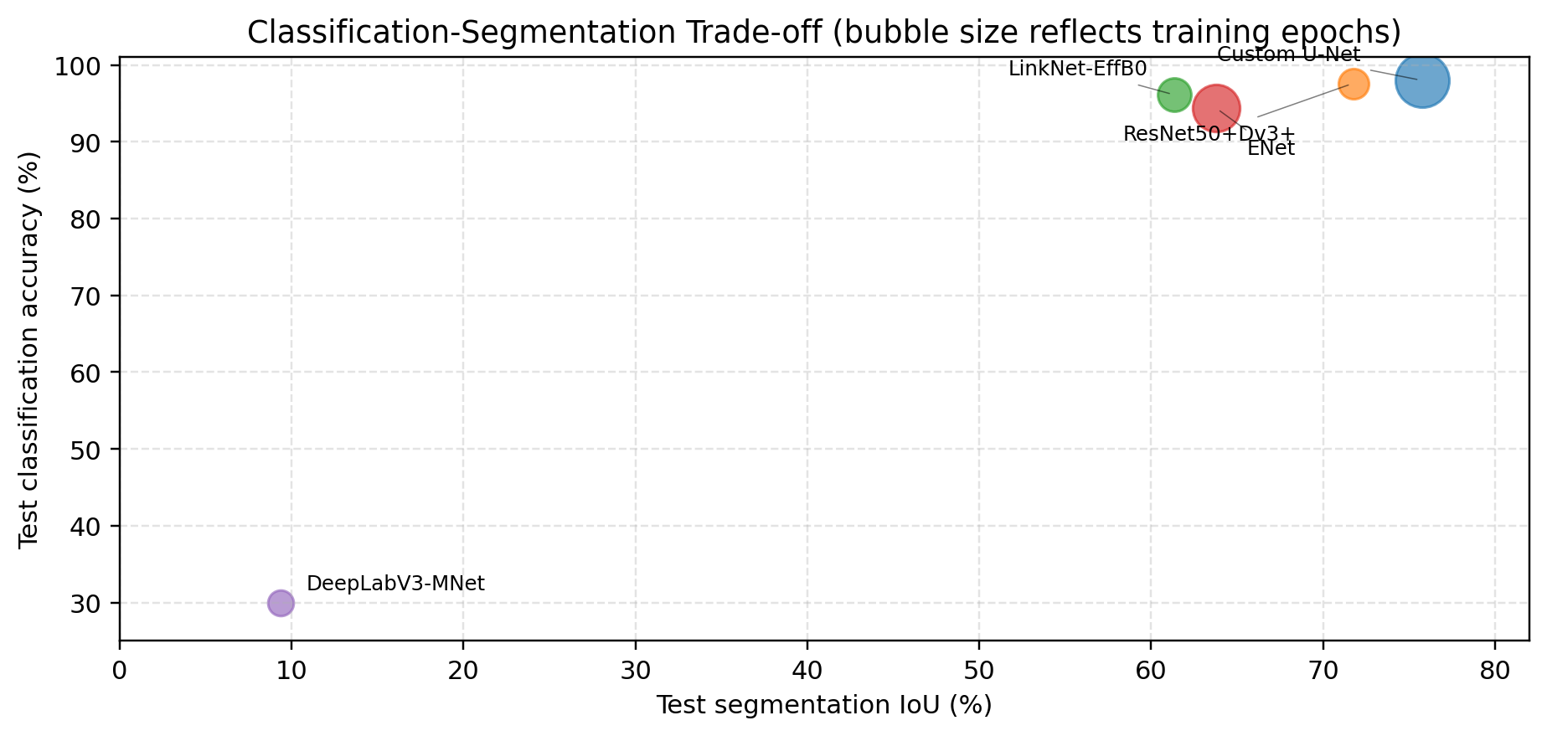
Figure 1. Classification-segmentation trade-off. The ideal model is the upper-right one: high accuracy and high IoU.

4. Final Quantitative Results
Model | Accuracy | Macro F1 | Balanced Acc | IoU | Dice | Macro AUC
Custom U-Net | 97.98% | 97.97% | 98.27% | 0.7575 | 0.8383 | N/R
ResNet50+Dv3+ | 97.60% | 97.90% | 97.89% | 0.7175 | N/R | N/R
LinkNet-EffB0 | 96.10% | 96.00% | 97.00% | 0.6135 | 0.7166 | 0.9964
ENet | 94.40% | 95.00% | 95.00% | 0.6376 | 0.6635 | 0.9975
DeepLabV3 | 30.00% | 12.00% | 25.00% | 0.0938 | 0.0938 | 0.4890

The Custom U-Net is the best overall model because it ranks first in segmentation IoU and Dice while also maintaining the highest classification accuracy. ResNet50 + DeepLabV3+ is the second. LinkNet and ENet are both strong, but their strengths differ.
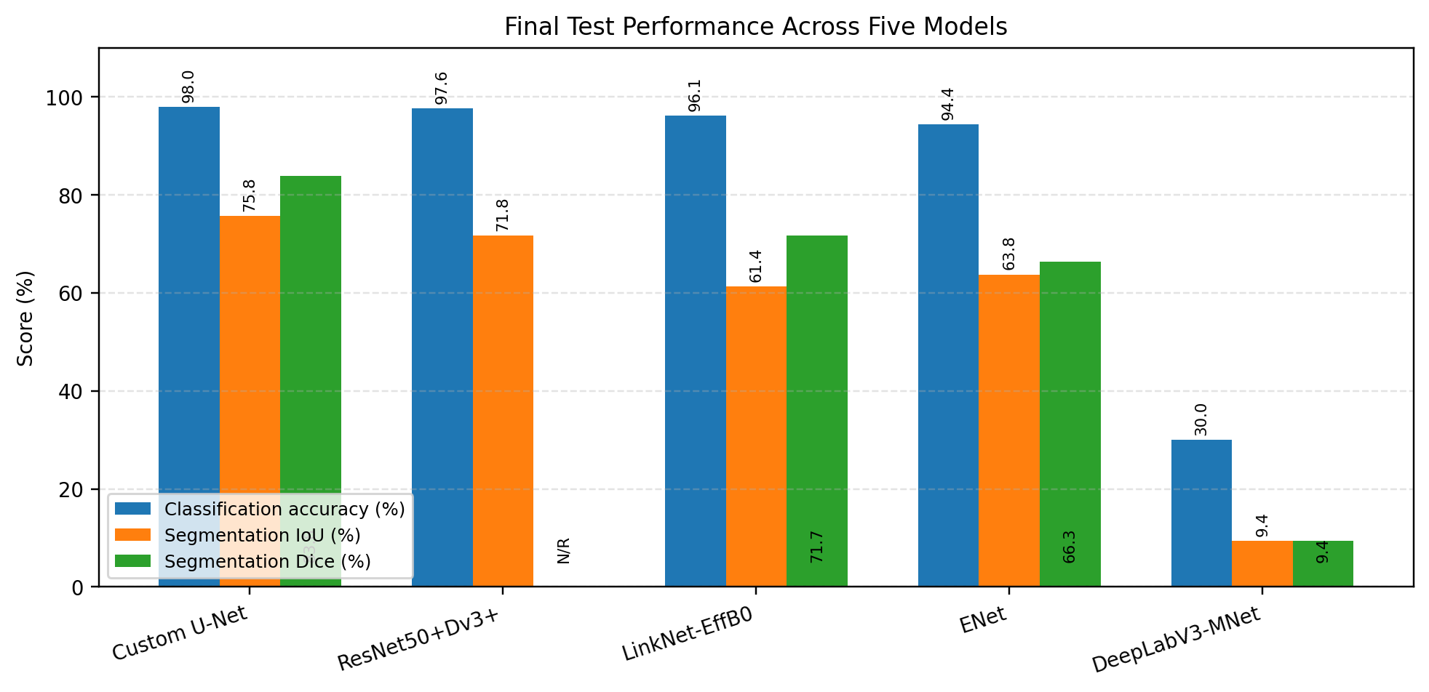
Figure 2. Final test performance comparison across classification accuracy, segmentation IoU, and Dice.

5. Training Dynamics and Convergence
Training dynamics confirm that performance depends strongly on epoch count, backbone initialization, and decoder suitability. The Custom U-Net improves steadily across 35 epochs and reaches its best validation IoU at the final epoch. ResNet50 + DeepLabV3+ achieves high IoU within 5 epochs. ENet needs more epochs to move from near-zero IoU to useful segmentation. LinkNet converges smoothly but peaks lower than Custom U-Net and ResNet50 + DeepLabV3+.

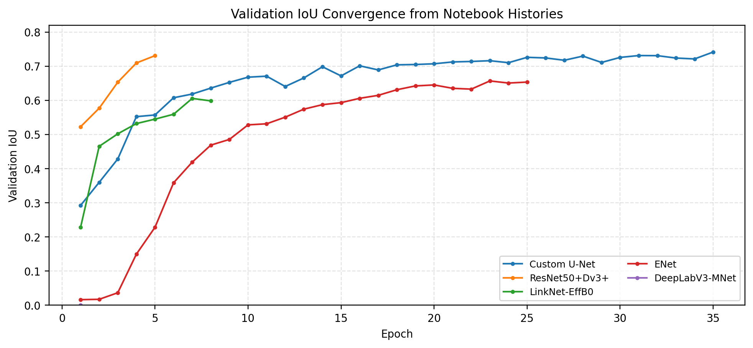
Figure 3. Validation IoU convergence from notebook histories.

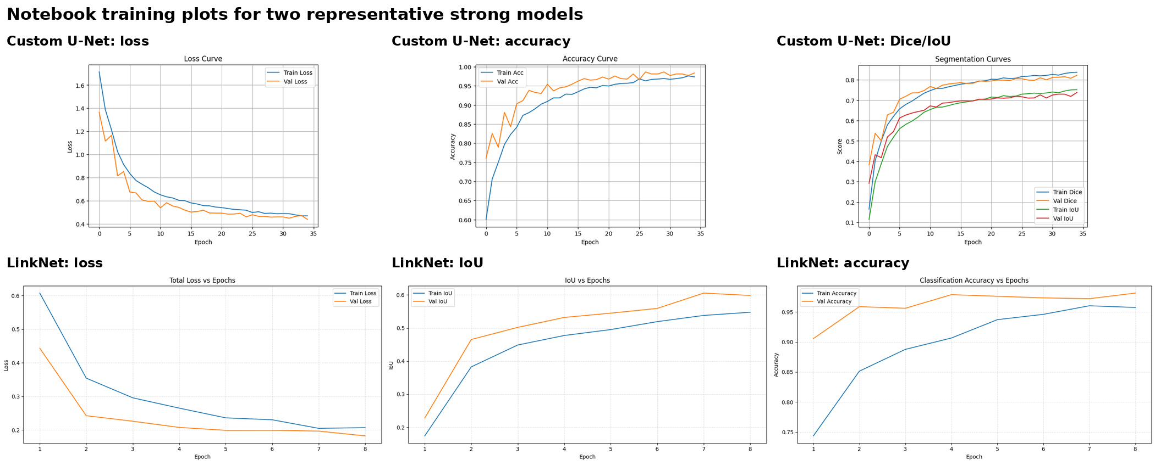
Figure 4. Original notebook training plots for Custom U-Net and LinkNet.

6. Classification Performance and Error Structure
The strongest models classify no_tumor almost perfectly. The most common remaining clinical confusion is between glioma and meningioma, which is expected because both can show MRI features that overlap visually. ENet has the clearest glioma-to-meningioma problem, while LinkNet has a meningioma-to-no_tumor weakness. DeepLabV3-MobileNetV3 fails because it predicts only the pituitary class.

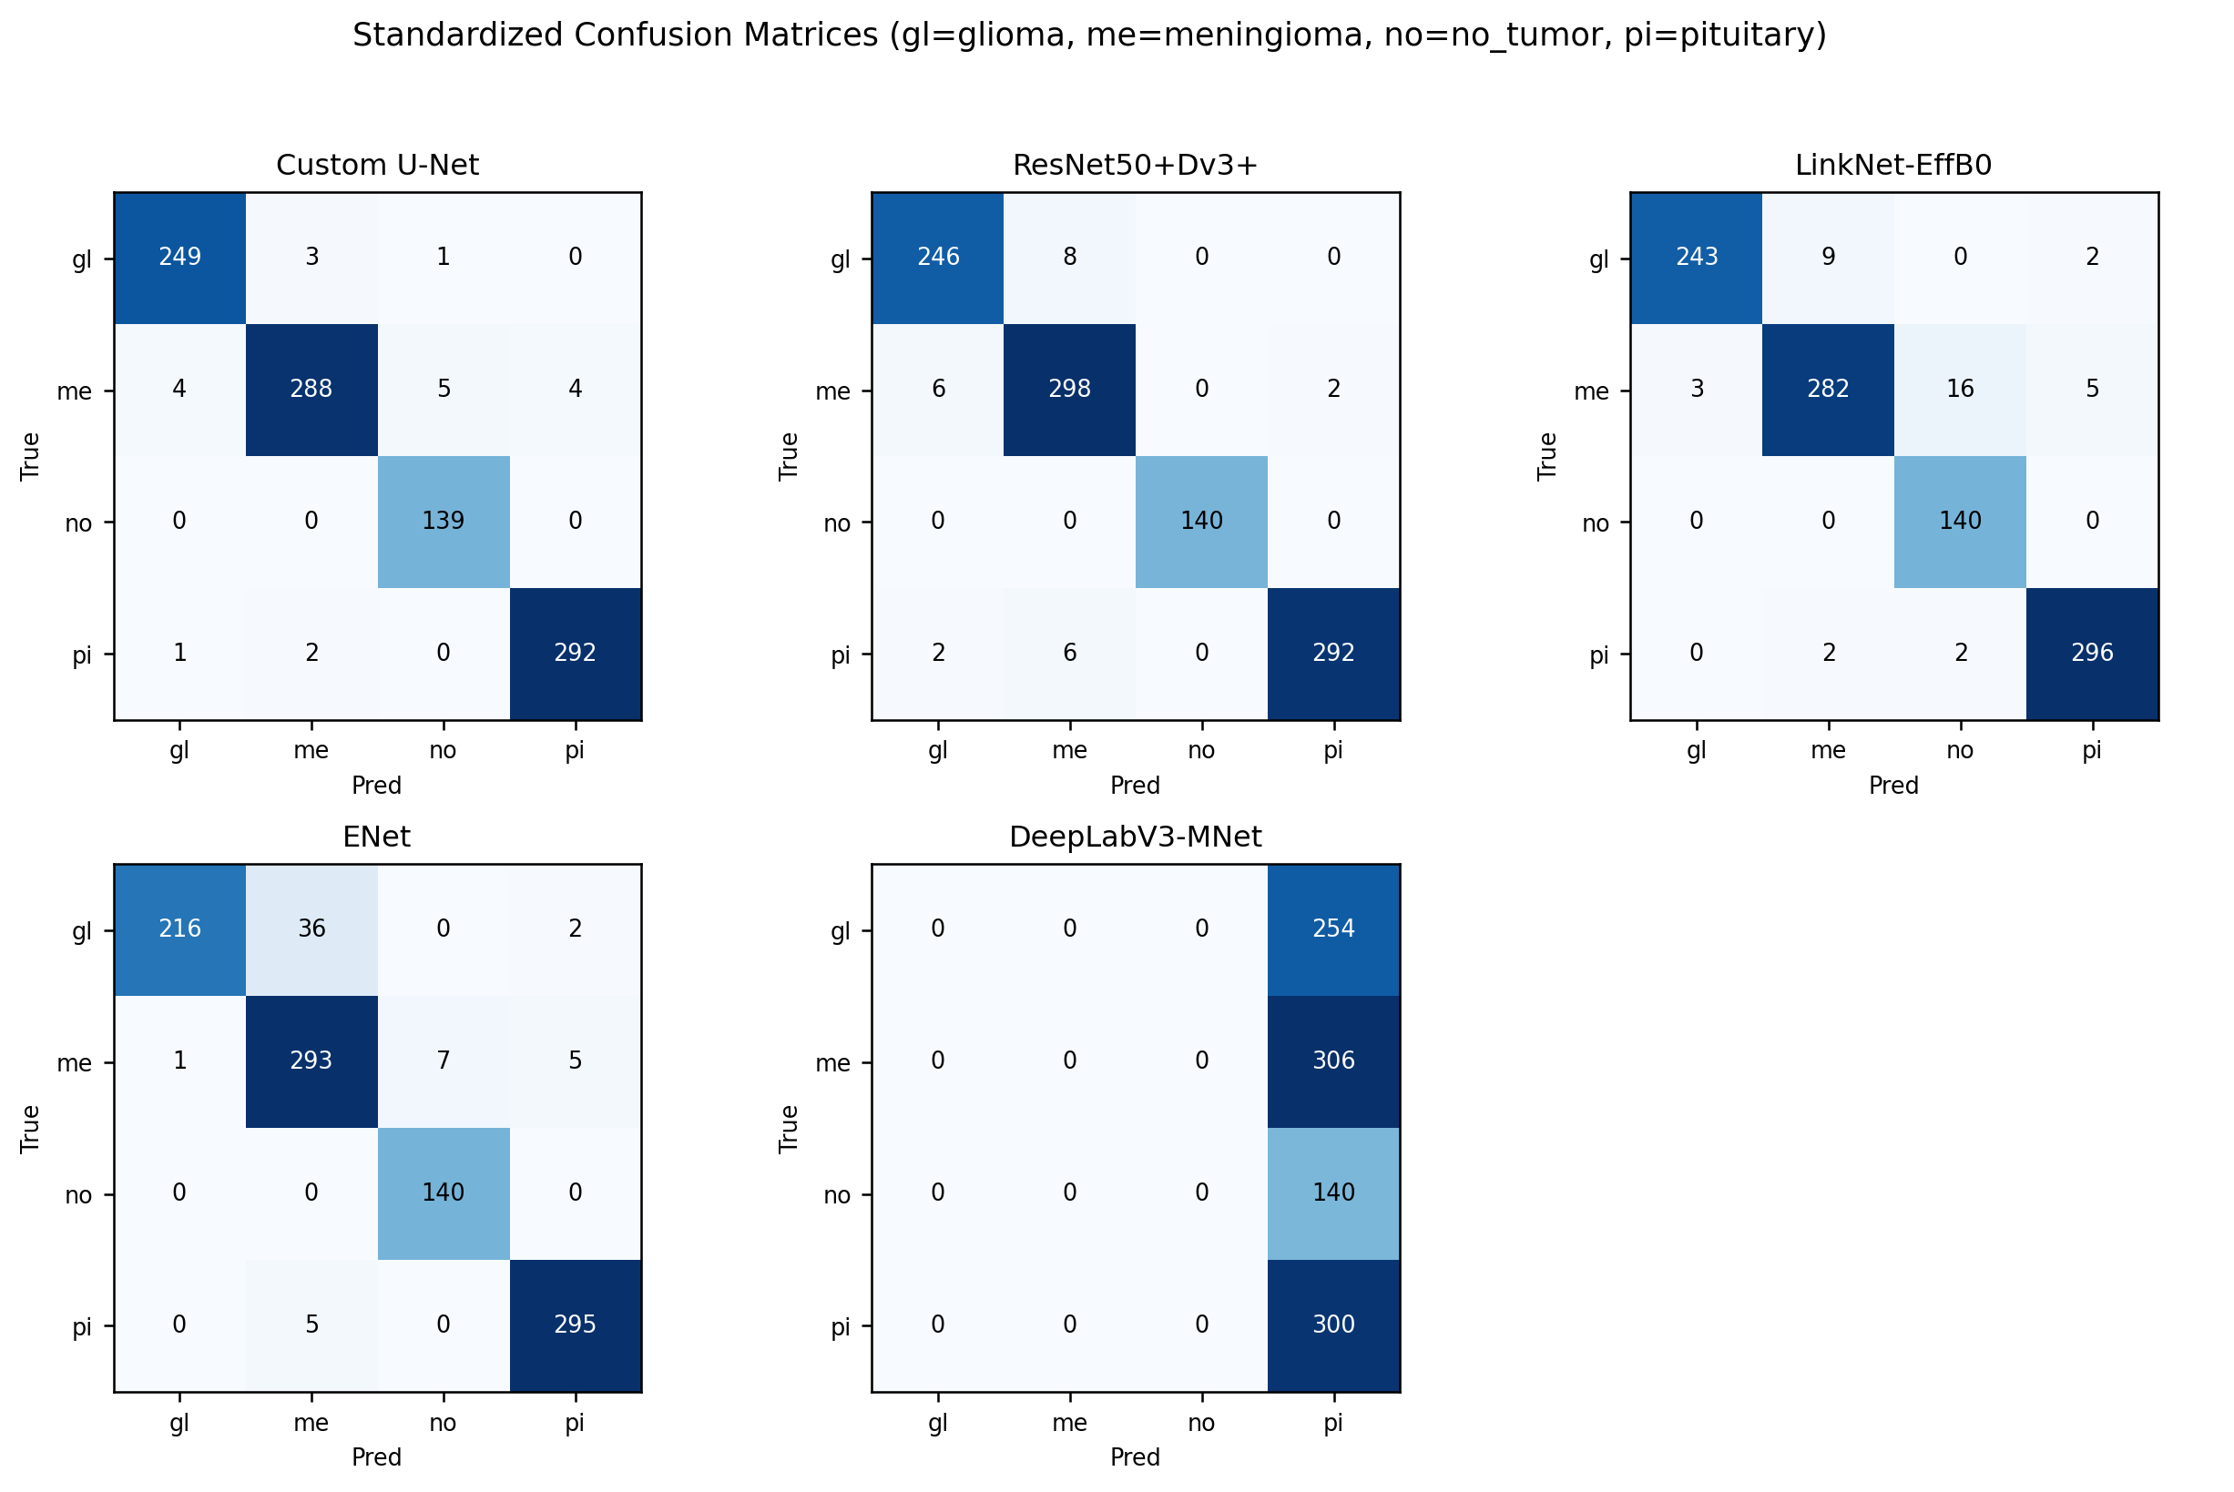
Figure 5. Standardized test confusion matrices for all five models.

7. Segmentation Performance and Qualitative Evidence
Model | Test IoU | Test Dice | Segmentation
Custom U-Net | 0.7575 | 0.8383 | Best spatial localization; predicted masks capture tumor regions.
ResNet50+Dv3+ | 0.7175 | N/R | Strong localization with only five epochs; Dice not printed in notebook.
ENet | 0.6376 | 0.6635 | Useful localization from a very small model, but mask quality is lower.
LinkNet-EffB0 | 0.6135 | 0.7166 | Dice is acceptable, but IoU indicates a stricter overlap weakness.
DeepLabV3-MNet | 0.0938 | 0.0938 | Mostly background predictions; high pixel accuracy is misleading.

Dice and IoU are more meaningful than pixel accuracy because MRI masks contain a large background area. DeepLabV3-MobileNetV3 reports high pixel accuracy (97.82%) despite very low IoU and Dice scores; this confirms that background dominance can mask segmentation failure.
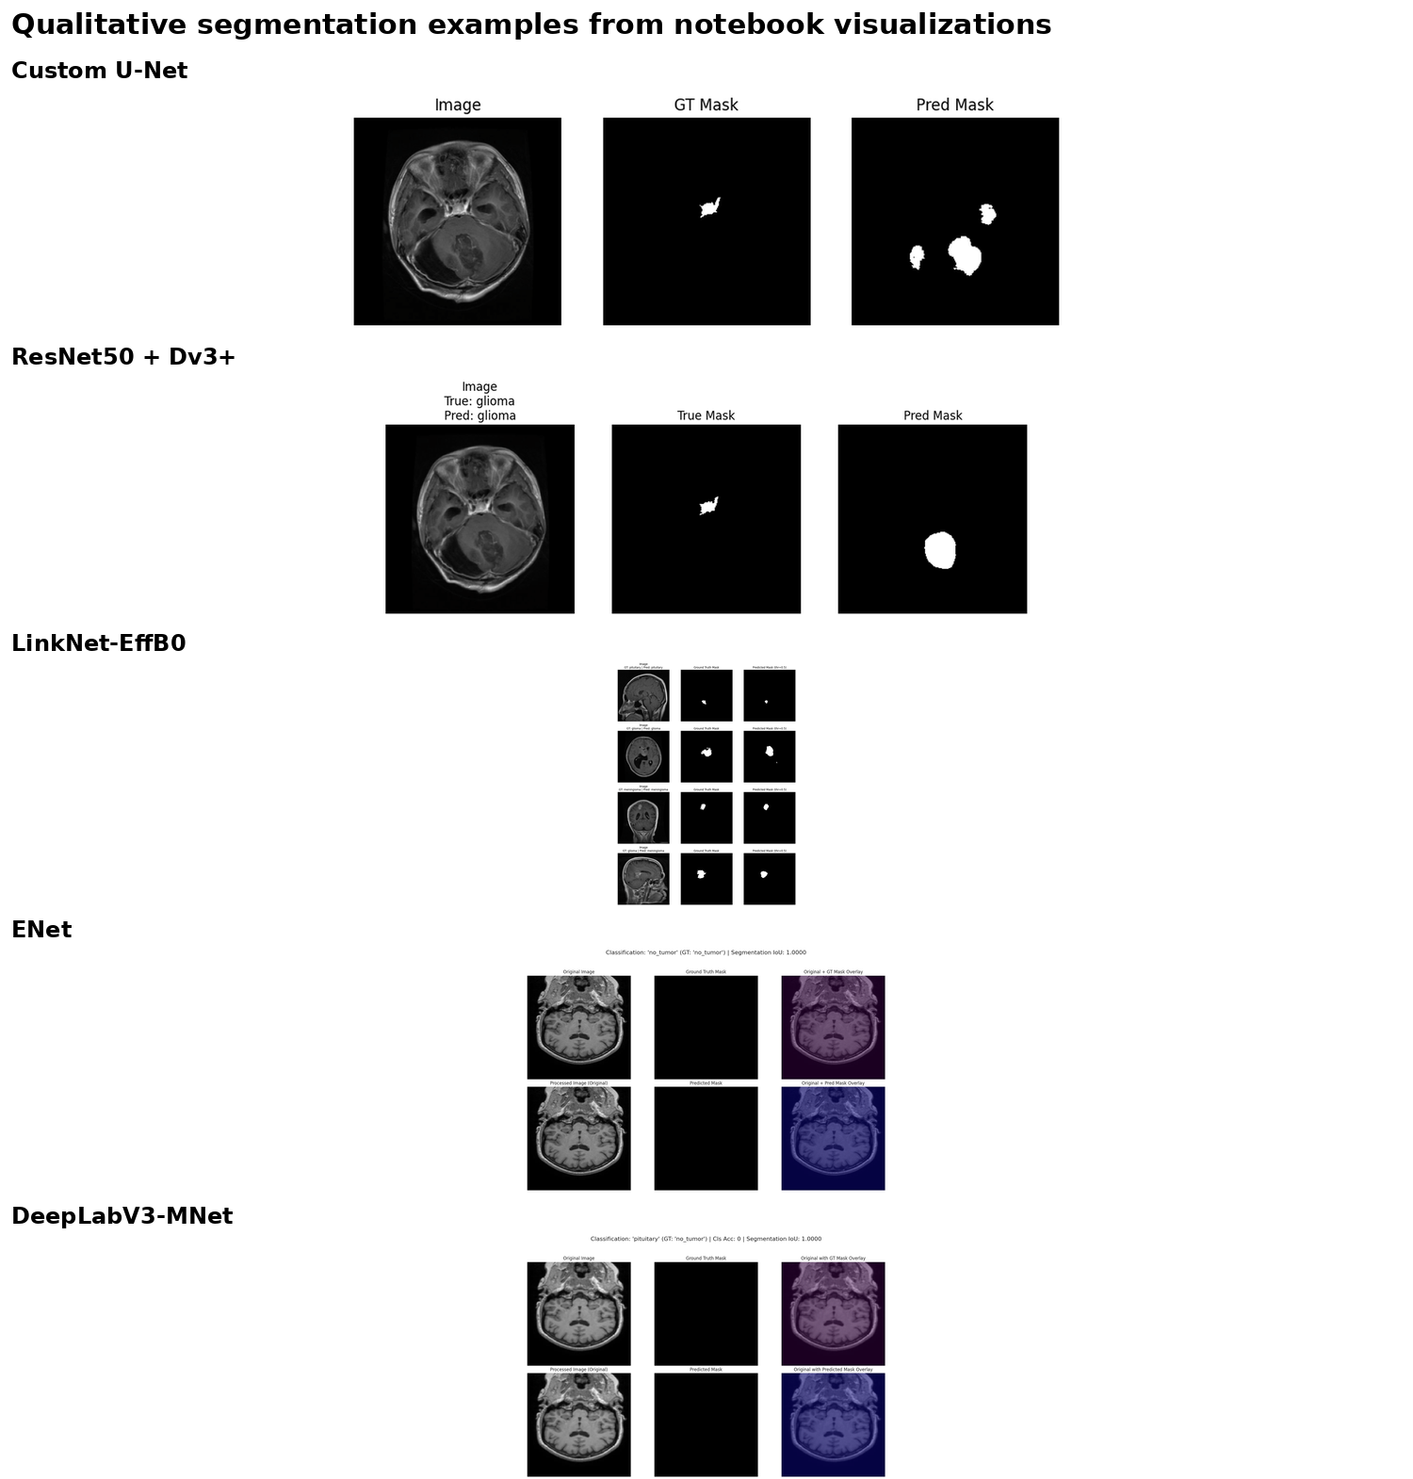
Figure 7. Qualitative segmentation examples copied from notebook visualization outputs.

8. ROC/AUC, Misclassification Counts, and Additional Plots
ROC/AUC plots were available for LinkNet, ENet, and DeepLabV3-MobileNetV3. LinkNet reports excellent class separability, with class-level AUC values of 0.9976 for glioma, 0.9900 for meningioma, 0.9999 for no_tumor, and 0.9979 for pituitary. ENet also reports near-perfect AUC values despite lower classification accuracy. DeepLabV3-MobileNetV3 has a macro-AUC of 0.4890, confirming class collapse rather than useful discrimination.
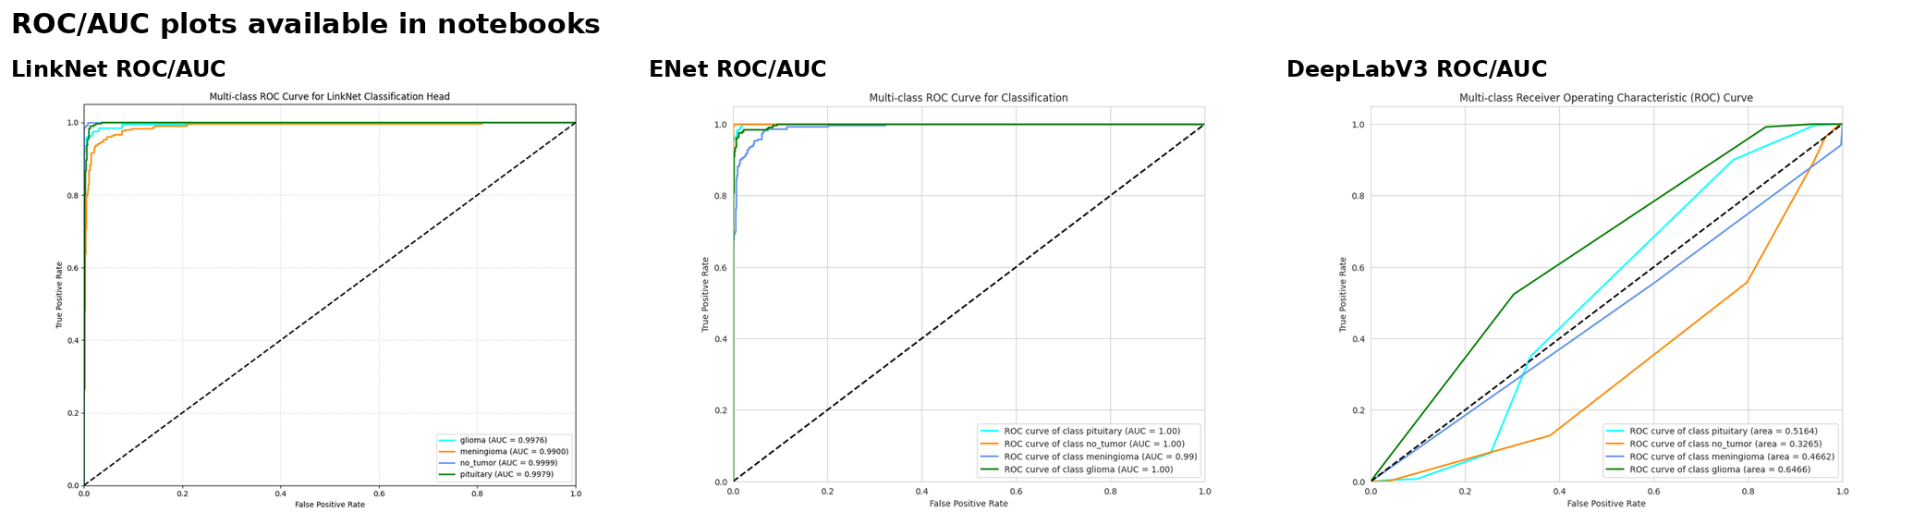
Figure 8. ROC/AUC plots available from the notebooks.

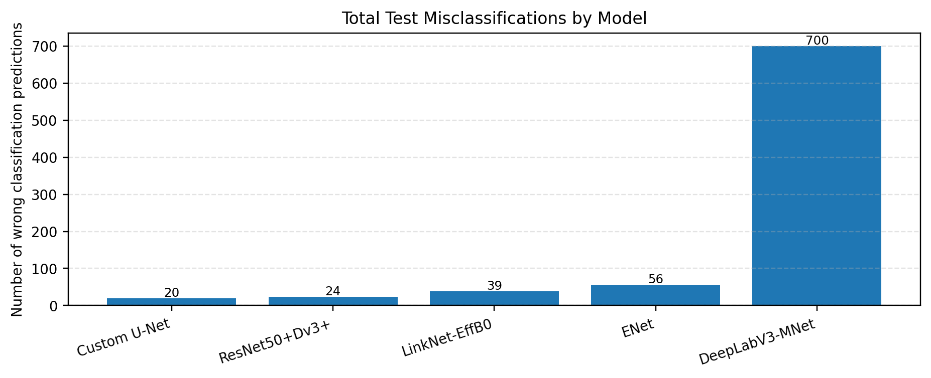
Figure 9. Total classification mistakes on the final test evaluation.

The error-count plot also shows why accuracy alone is insufficient. Custom U-Net and ResNet50 + DeepLabV3+ have a few errors, but their segmentation results still differ. ENet has more errors than LinkNet, yet its IoU is better. Therefore, the project should report classification and segmentation metrics together.

9. Best Performed Model and Extended Model Comparison
• Model: Custom U-Net Multitask.
• Reason: highest combined result, with 97.98% classification accuracy, 0.8383 Dice, and 0.7575 IoU.
• Key strength: best tumor localization while keeping classification near 98%; only minor errors remain in visually similar tumor classes.
The best model is Custom U-Net Multitask because it delivers the best overall performance, not just the best single metric. It has the highest classification accuracy, highest segmentation IoU, highest Dice, and clear feature separation in the UMAP output. The result is also clinically meaningful because it combines a near-98% diagnostic decision with the strongest tumor mask localization.
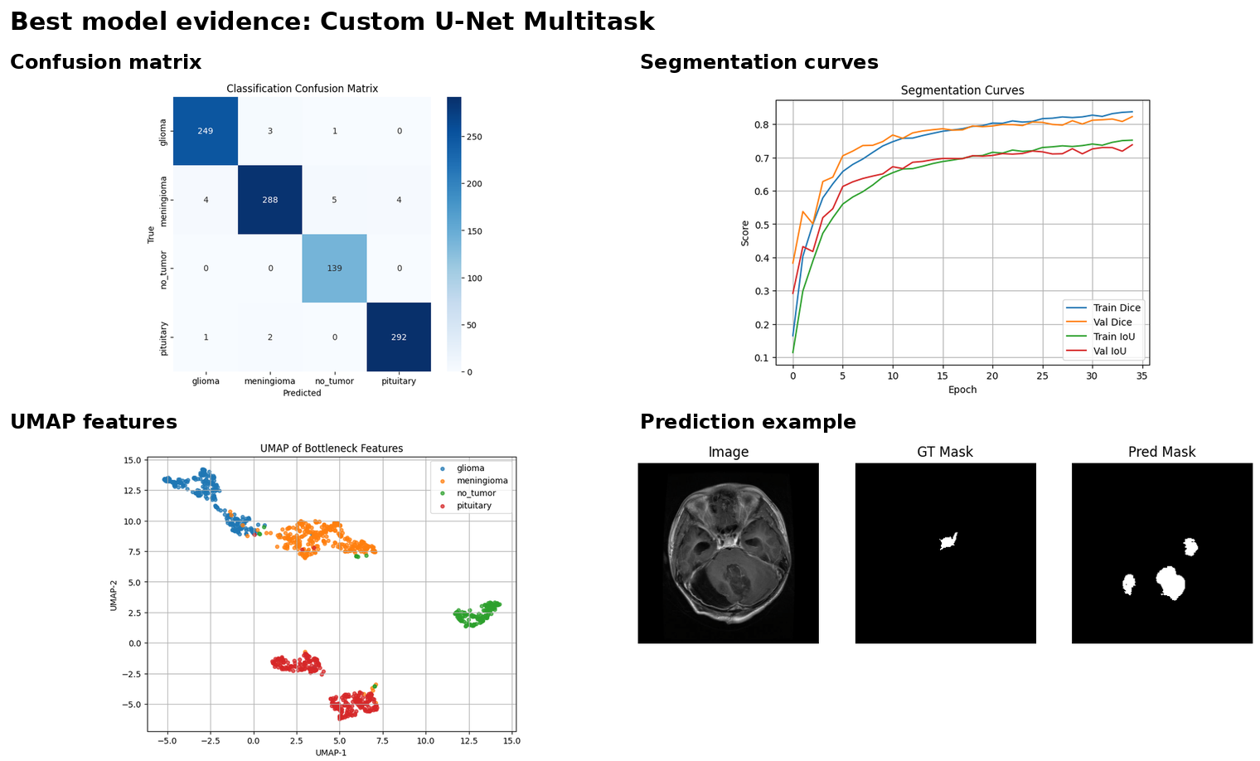
Figure 10. Custom U-Net evidence: confusion matrix, segmentation curves, UMAP features, and prediction example.

10. Limitations
• The experiments are not completely controlled: image size, RGB/grayscale input, duplicate removal, epoch count, and checkpoint selection differ across notebooks.
• Some metrics are not uniformly available. ResNet50 + DeepLabV3+ does not report Dice or ROC-AUC in the notebook, whereas LinkNet and ENet do.
• The Custom U-Net test set is slightly smaller after duplicate removal, so its results should be interpreted as cleaned-test performance.
• The DeepLabV3-MobileNetV3 result reflects undertraining and lack of pretrained initialization, not the full potential of the architecture.
11. Future Work
• Rerun all five models under one controlled pipeline with the same train/validation/test split, same resolution, same augmentation policy, and same epoch budget.
• Use hard-example sampling or class-aware loss for glioma and meningioma to reduce the most persistent tumor-type confusion.
• Evaluate tumor-only segmentation separately from blank-mask cases and report boundary metrics in addition to Dice and IoU.
• Apply stronger tumor-focused losses such as Focal Tversky or Dice-Focal loss and compare post-processing of predicted masks.

Conclusion
This extended comparison confirms that multitask learning is effective for the BRISC2025 brain MRI project when the model is trained sufficiently and uses an architecture suitable for segmentation. Custom U-Net Multitask is the best overall model, with 97.98% classification accuracy, 0.8383 Dice, and 0.7575 IoU. ResNet50 + DeepLabV3+ is the strongest secondary model, LinkNet EfficientNet-B0 provides high AUC and strong classification, and ENet is the most efficient lightweight model. The DeepLabV3-MobileNetV3 experiment is retained only as an undertrained baseline that requires more epochs and better initialization. For the final project narrative, the Custom U-Net should be presented as the primary model, supported by ResNet50 + DeepLabV3+ as a powerful alternative and ENet as the efficient deployment option.

